You are given two **non-empty** linked lists representing two non-negative integers. The most significant digit comes first and each of their nodes contains a single digit. Add the two numbers and return the sum as a linked list.

You may assume the two numbers do not contain any leading zero, except the number 0 itself.

**Example 1:**

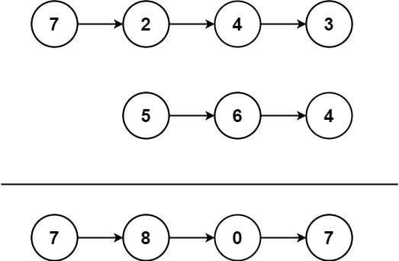

Input: l1 = [7,2,4,3], l2 = [5,6,4]  
Output: [7,8,0,7]

**Example 2:**

Input: l1 = [2,4,3], l2 = [5,6,4]  
Output: [8,0,7]

**Example 3:**

Input: l1 = [0], l2 = [0]  
Output: [0]

**Constraints:**

* The number of nodes in each linked list is in the range [1, 100].
* 0 <= Node.val <= 9
* It is guaranteed that the list represents a number that does not have leading zeros.

**Follow up:** Could you solve it without reversing the input lists?